Name: Harshalk

Std: TYBSCIT

Roll no: 16

Subject: DMBI

(Practical No 4a,4b)

Signature:

**Practical 4A – Create the cube with corresponding dimension and fact table based on OLAP**

Continue from the above practical.

In Solution Explorer select Cube which opens a dialogue box

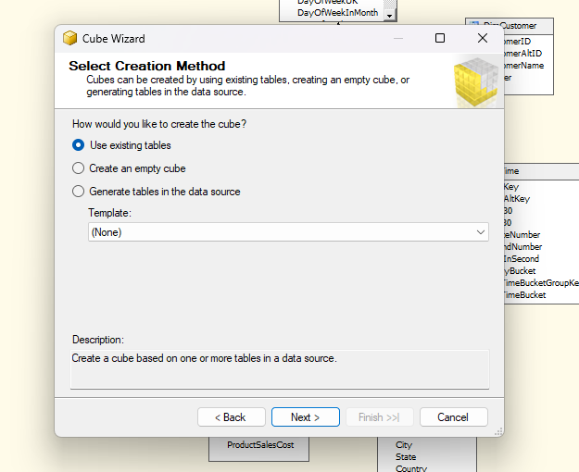

Select the tables – FactProductSales, DimProduct, DimTime and click on Next.

Select all the measures to include in the cube and click on Next.

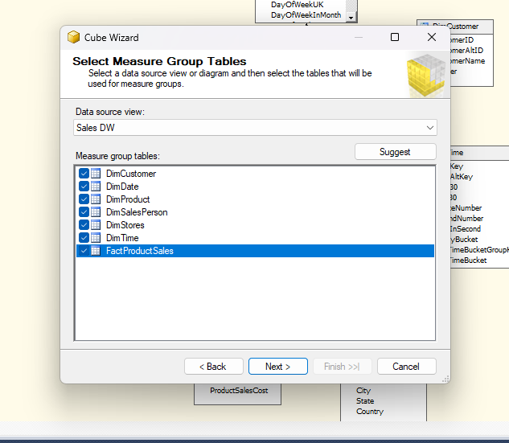

The relationship will be displayed on the screen.

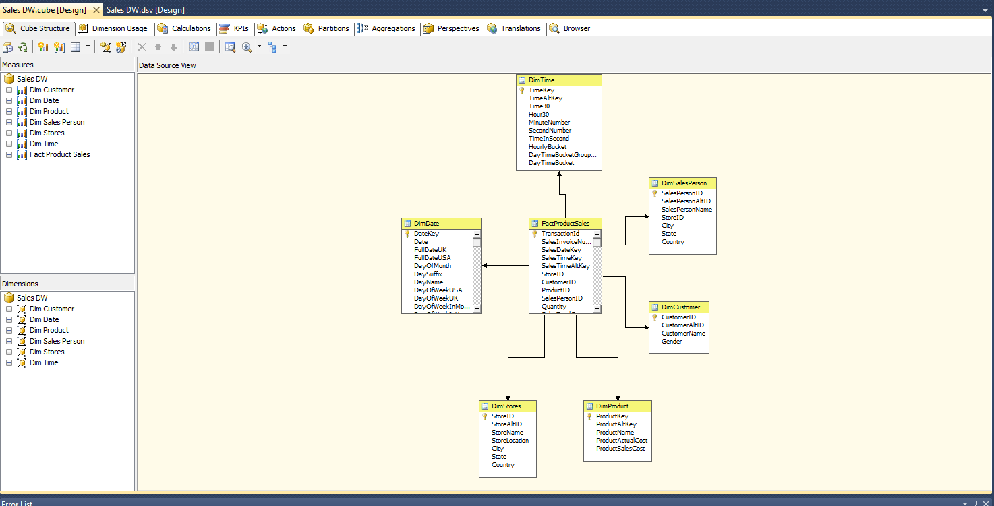

Drag and drop Year, Quarter and Month to the Attributes.

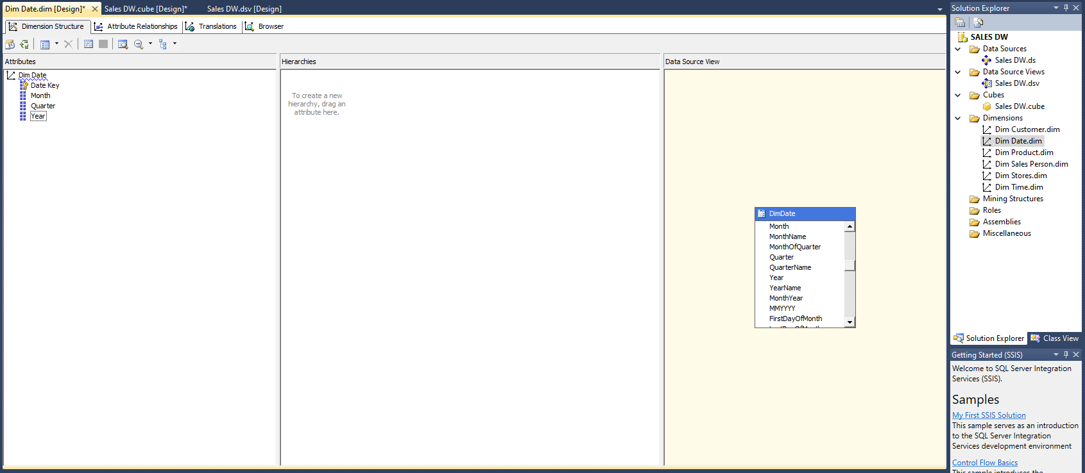

Drag and drop the attributes into the same Hierarchy.

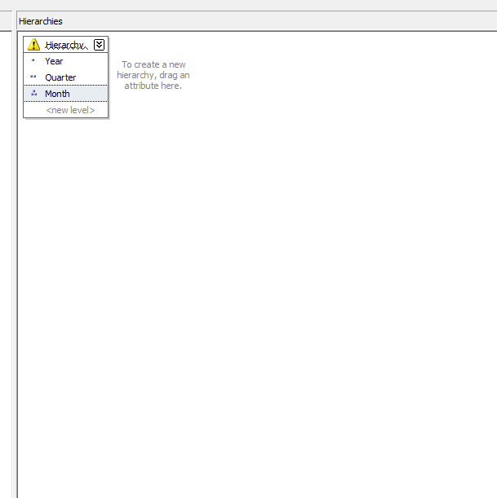

And just save and build

Right click on the file name and select Properties

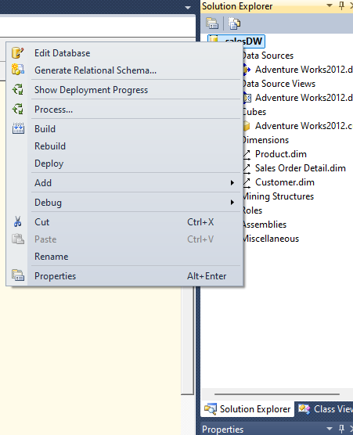

In Build make sure everything is correct

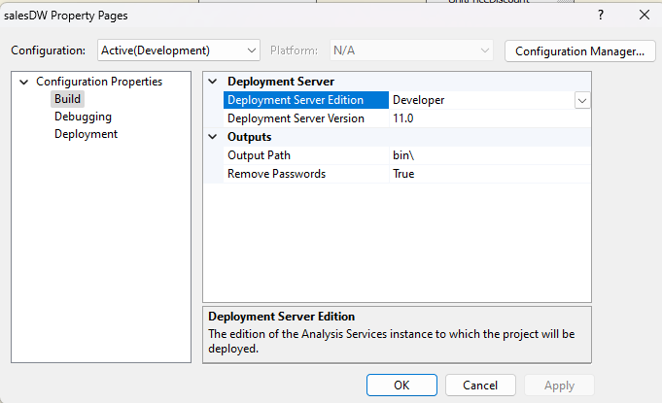

In Deployment, make Processing Option as Full instead of Default. Server Mode as Deploy All instead of Deploy Changes Only. Server as the server name used till now instead of localhost. Apply these changes.

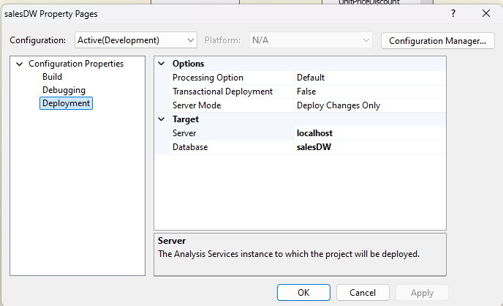

Right click on the file name and click on Deploy to deploy the project.

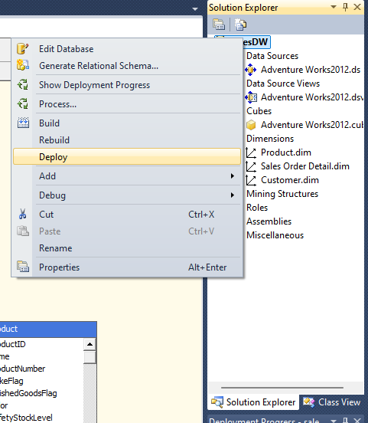

Deployment is successful

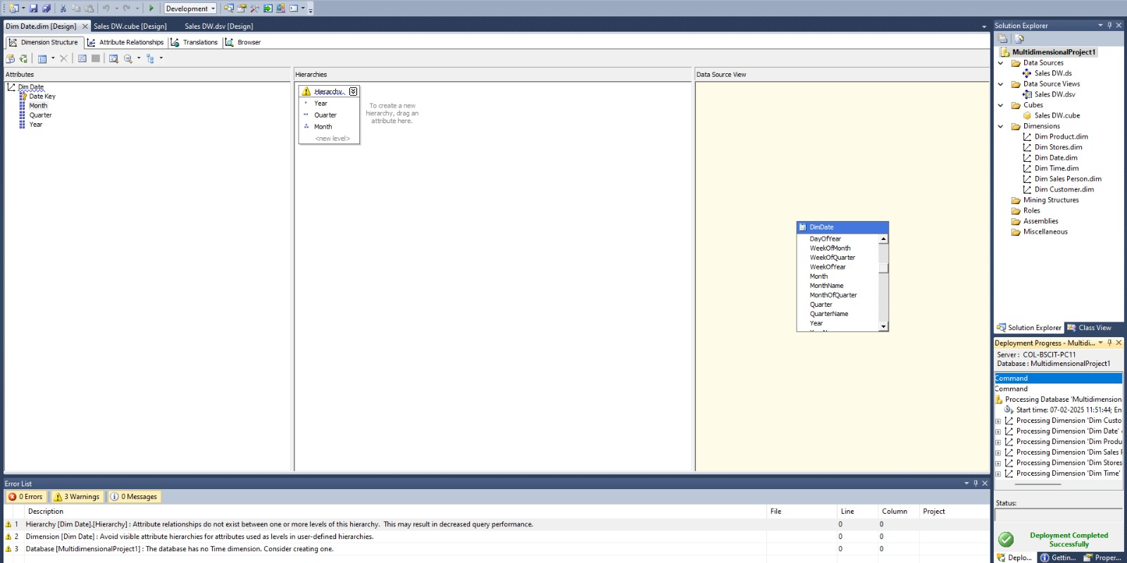

Practical 4B – Perform Multi-Dimensional Expressions (MDX) queries for OLAP database

Continue from the above practical. To verify, in SQL Server Management right click on the file name in Object Explorer and click on Browse.

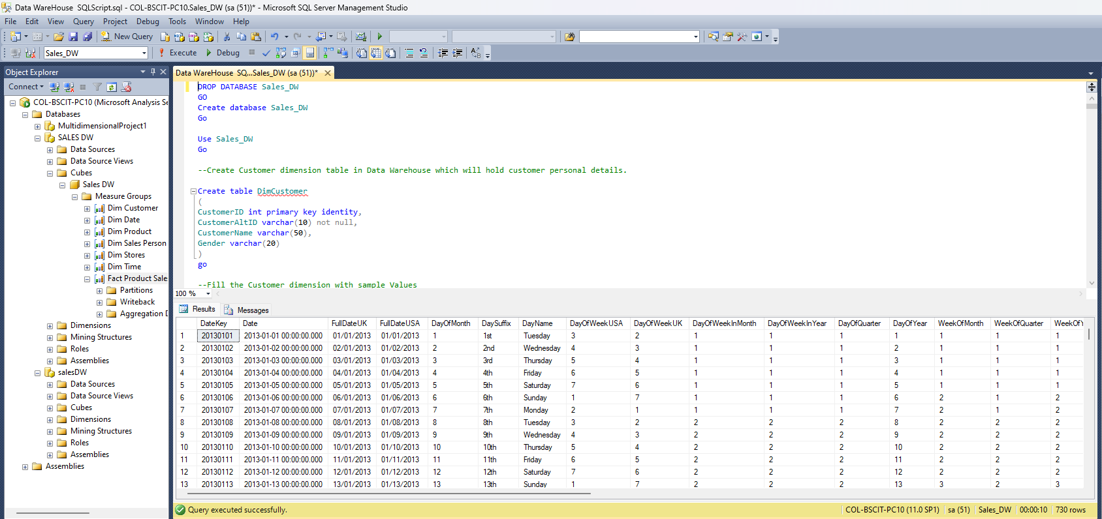

**Practical 4B – Perform Multi-Dimensional Expressions (MDX) queries for**

**OLAP database**

Continue from the above practical.

To verify, in SQL Server Management right click on the file name in Object Explorer and click on Browse.

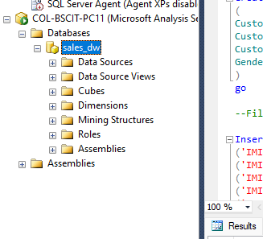

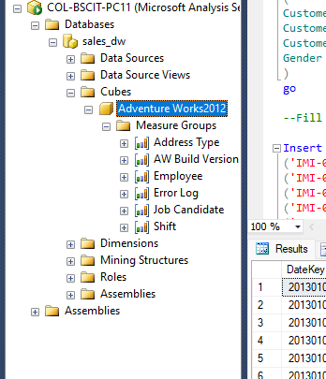

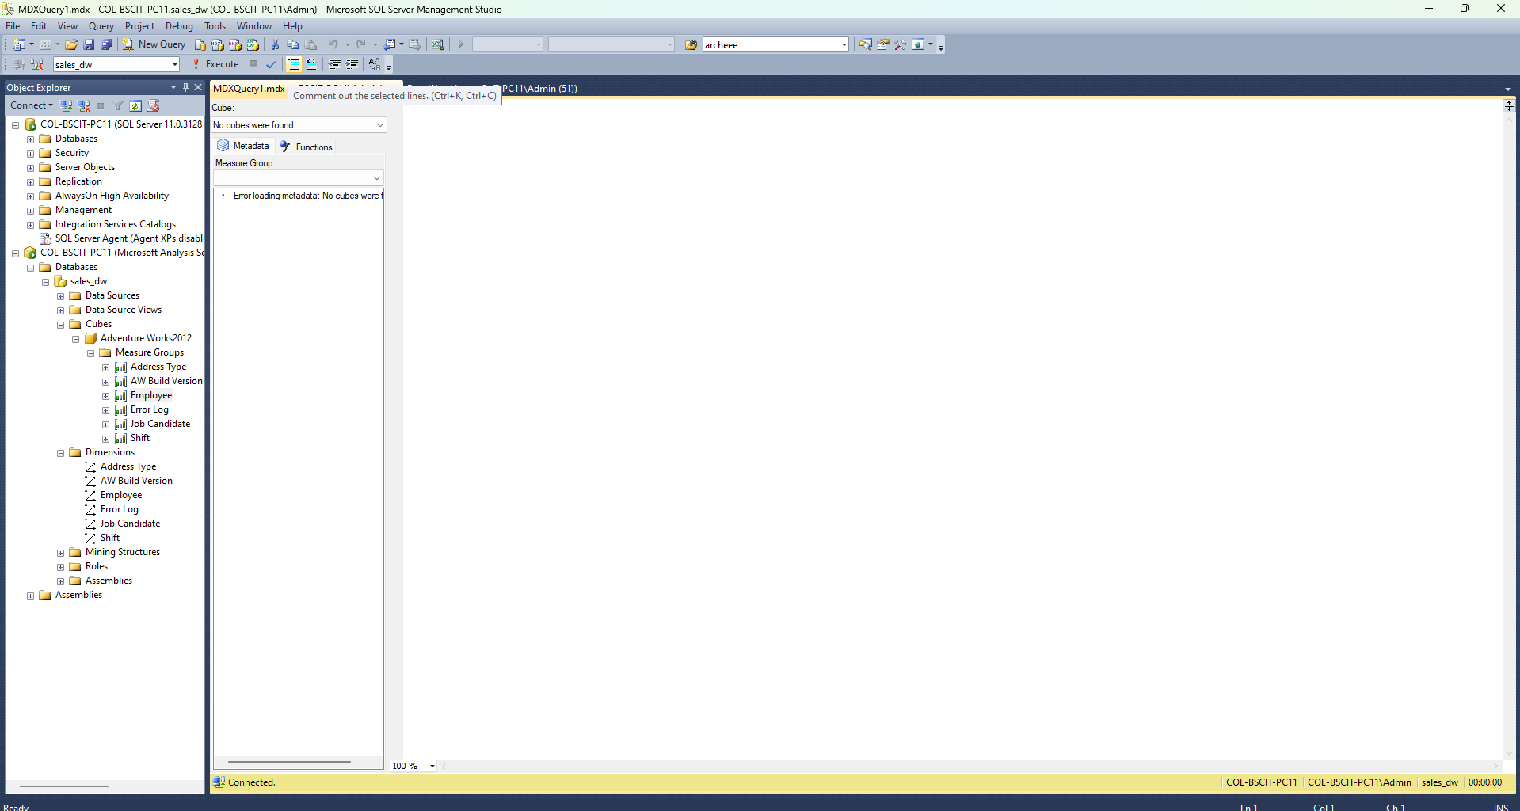

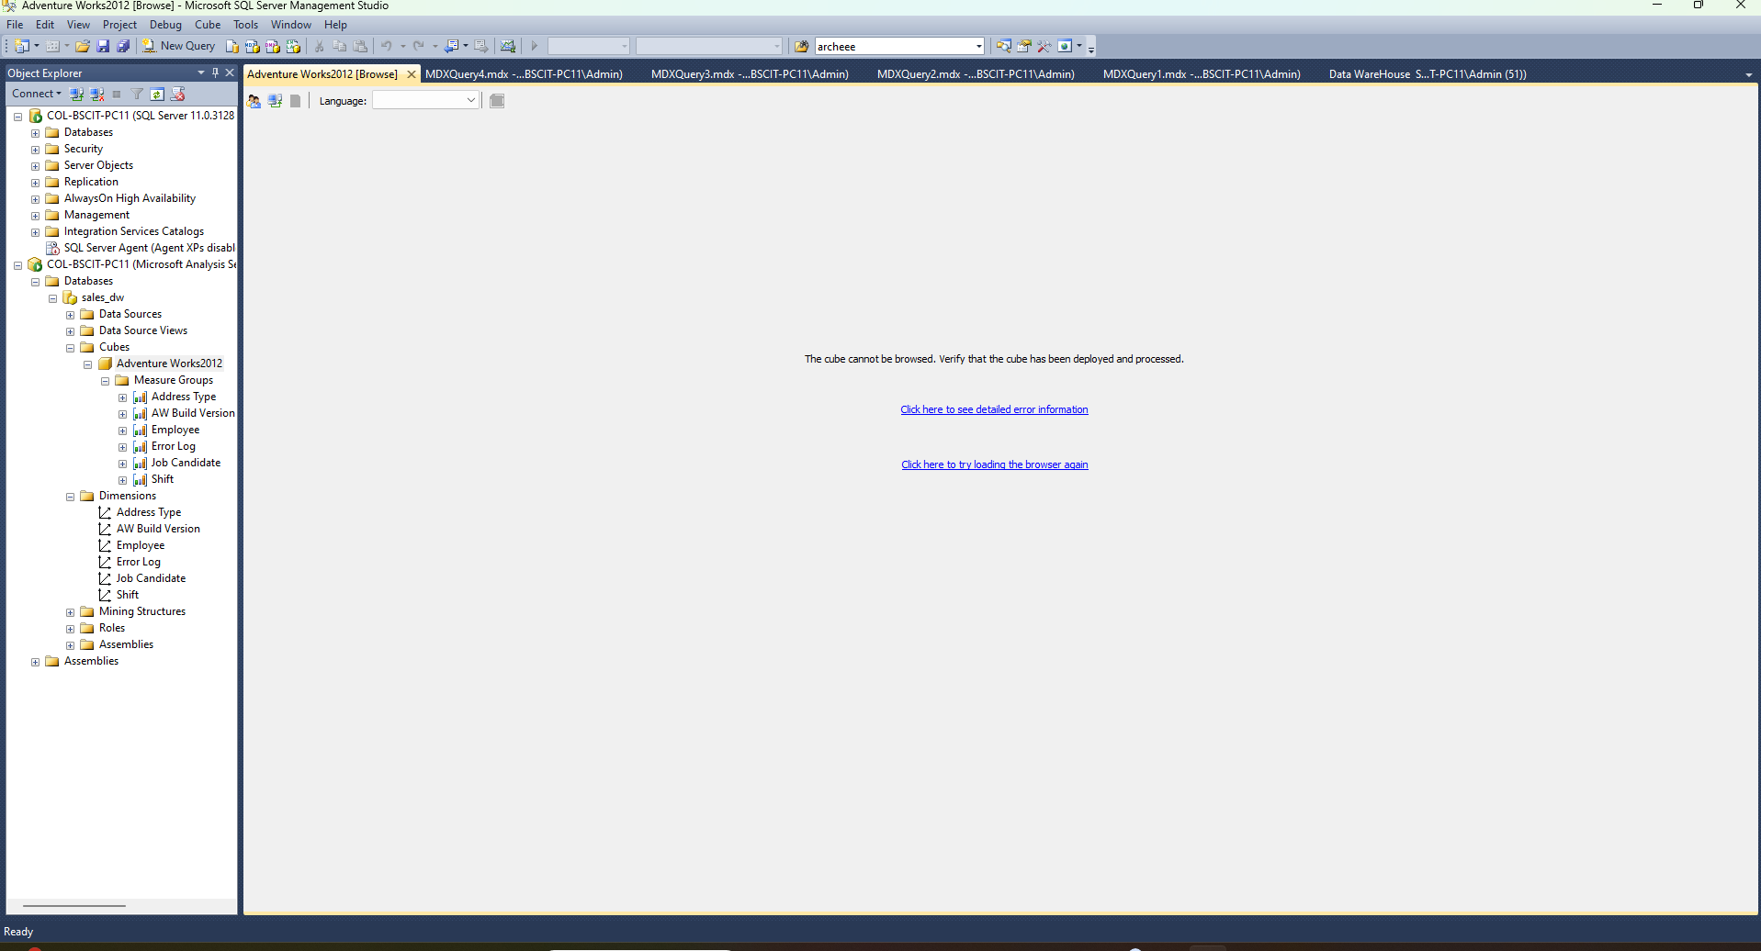

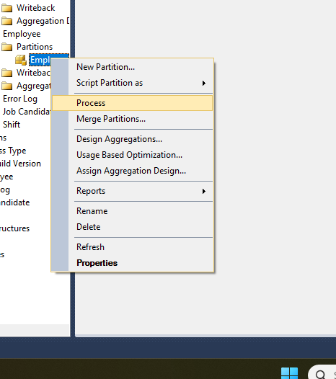

Click on OK.

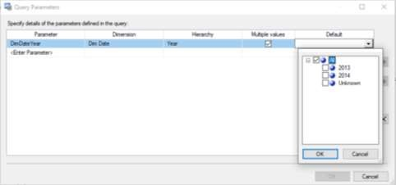

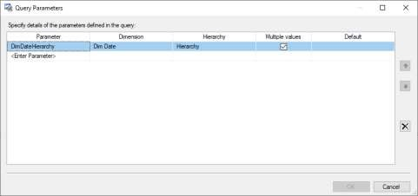

The entries will be shown on the screen.

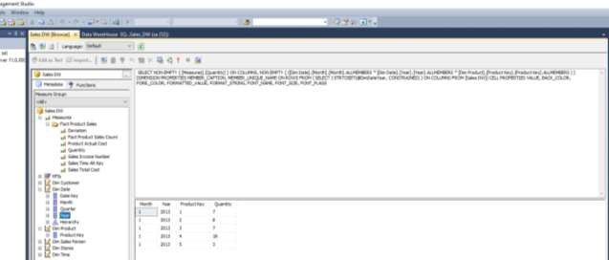

Right click on the file name and select Process.

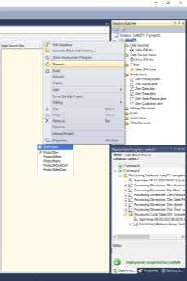

Select the file and click on Run.

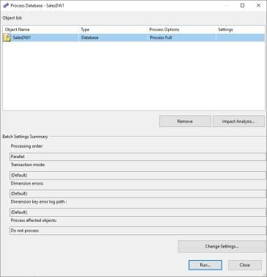

Process succeeded is the status.

